Milestone 1 Report

*COMPSYS 704: Advanced Embedded Systems*

*Project 1*

*Group 7*

*Beck Busch (bbus692)*

*Frank Shen (fshe388)*

*Rufaro Manjala (rman429)*

# 1. Introduction

Advantech Ltd., a company for manufacturing and delivery of sensitive and high value bottled liquids, have decided to build a new manufacturing facility that will automate the manufacturing process within the existing facility, provide advanced system for monitoring and controlling environmental conditions and access and security control.

This project is to develop this solution leveraging IoT concepts, synchronous programming and system-level designing. This is a milestone report documenting the progress and decisions made for this project.

# 2. Brief

The solution is facility wide. Incorporated in multiple parts of the physical facility as well as in the purpose of the facility, it has the following requirements:

* A developed Automated Bottling System, as this is facility’s purpose, to output orders of bottled goods
* Be able to monitor who is within the facility as well as specifically where they are
* Be able to provide security in the form of only allowing selected personnel in general and specific areas of the facility (e.g. restricted access to the main office)
* Continuously monitor and adjust the facility's climate factors such as humidity and heat to desired conditions. Even able to adjust the climate of specific areas differently within the facility
* Receive and process orders from registered customers for bottling

These are the high-level requirements from which more detailed and specific requirements stem from.

# 3. Overall Conceptual design

In this section the overall intended design is explained here. A diagram expressing the overall design can be seen below at Figure 2 .

As a team, a decentralized system has been opted before, with the different functionalities of the overall system managed separately. This is due to a decentralized design allowing for a more modular design of the system. Each member of the team will be able to develop functionalities with not much concern for clashing with other team members. Additionally, this means it spreads the burden of processing and running of functionalities improving overall performance. Finally, this method has security benefits as the failure of one functionality will not necessarily mean the breaking of the whole system.

The overall design is broken into 4 subsystems. The following subsections explain briefly their functions. Links are used for communications between sub-systems. The system will receive data from sensors embedded within the physical environment and output signals that will drive actuators.

## 3.1 Automatic Bottling System (ABS)

A central part to Advantech, this handles the grabbing, filling, capping and passing on of the bottles. From orders received liquids are mixed to create the ordered product. It is made of 5 components that are separate stations

* Capping Station – A station for the grabbing of bottle and tightening the cap to ensure the product inside does not spill out
* Conveyor Belt – A belt for initially loading bottles onto the ABS and sending them on once they have gone through it
* Filling Station – A station for filling the presented bottles with different products dependent on the bottle and/or next order.
* Rotary Table – This component is tasked with shifting the bottles onto the next stage of the ABS

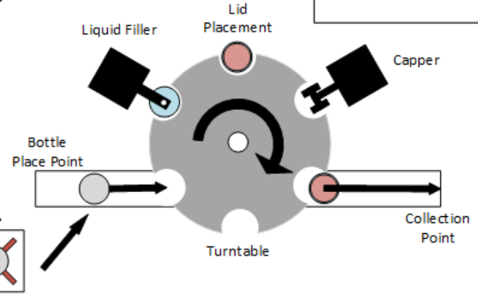

Figure 1 - Graphic of ABS

## 3.2 Access Control System (ACS)

Access Control System - Access Control System (ACS) controls movement of the personnel in the space. Controlling the main access of the facility as well as specific rooms for all personnel that interact with the facility. In addition, it will continually track the location of all within the facility and make appropriate alerts when required about people entering restricted areas such as the ABS area. It will leverage the use of ID tags, badges and RF scanners for this system.

## 3.3 Environment Control System (ECS)

Environment Control System (ECS) will ensure a stable temperature and humidity while the facility is in use or operational, and lighting conditions will be managed to be appropriate for the time of the day. It will also monitor for fires or smoke in the premises and will activate the fire extinguishing system, while raising an alarm and alerting emergency services when fires are detected.

## 3.4 Product order system (POS)

Product order system (POS) allows the customers to launch orders directly on-line from their computers (for example, through a web-based application or some dedicated application). The order will contain information on liquid specification and number of bottles. It will communicate these orders directly to manufacturing (ABS)

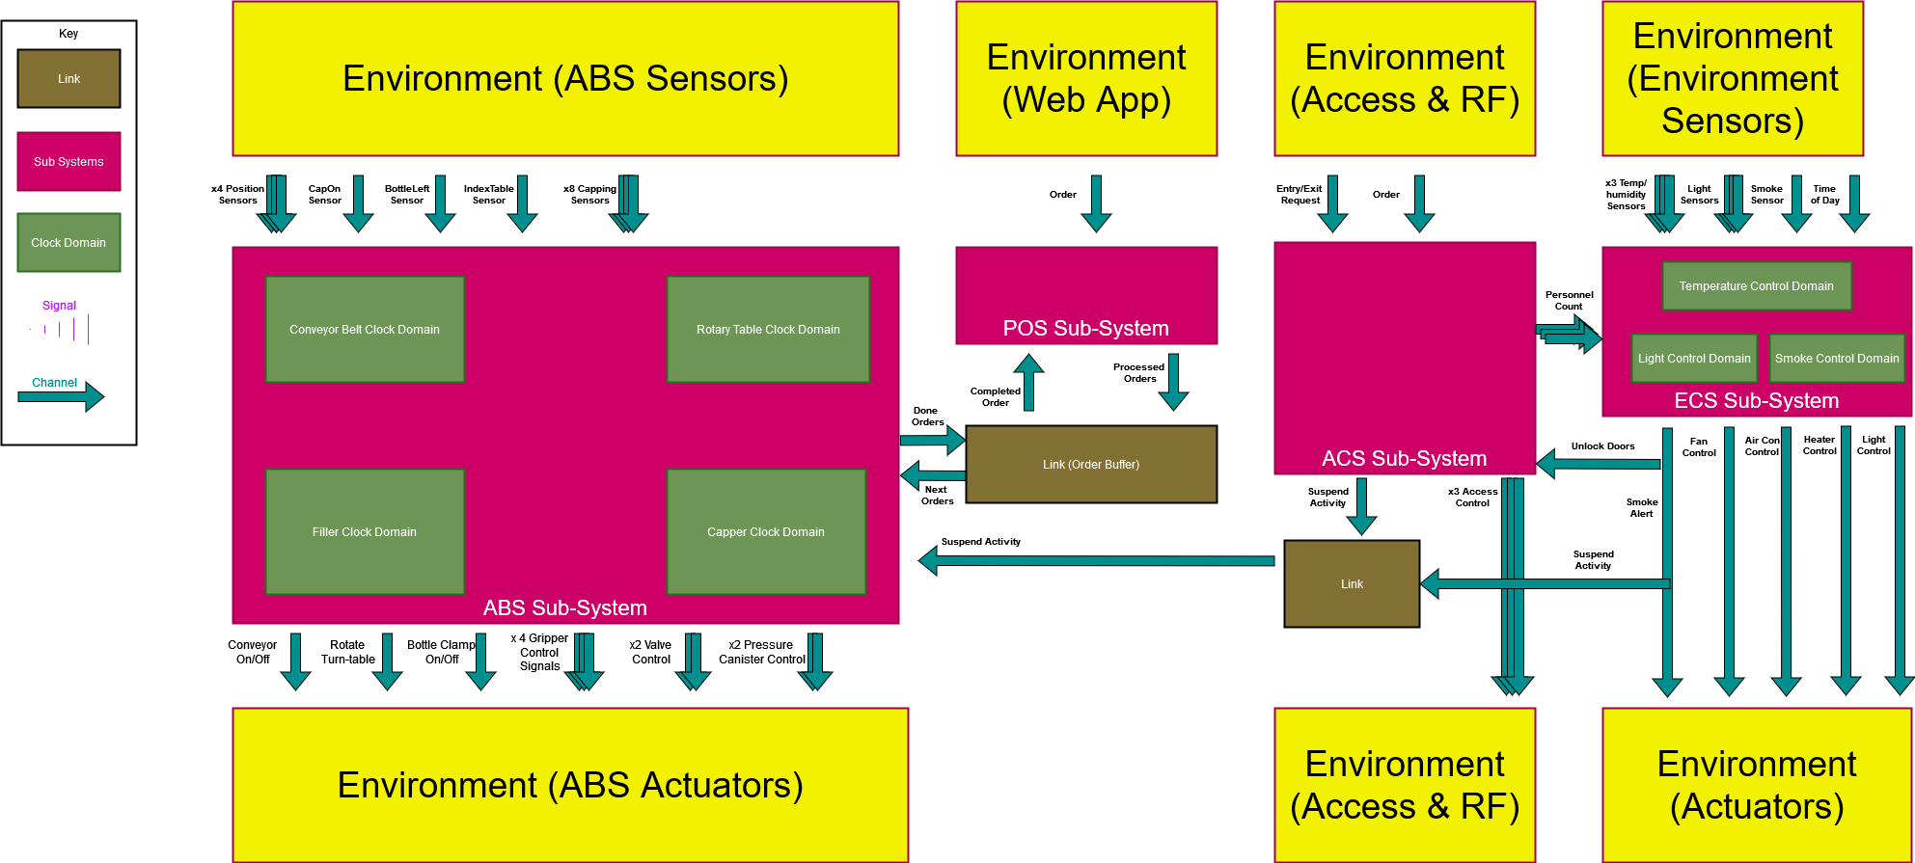

Figure 2 - Block Diagram of Overall System

# 4. System J and Java

For the development of the system, the team will be utilising SystemJ and Java software. The following is a section to further explain these two tools and their role they will play.

## 4.1 System J

The main development tool for the system design. System J is chosen programming language for the system-level design. It can be used to model and design control parts of the target systems as well as of simulated parts, e.g. plant, in the same model. SystemJ has abstractions that support and utilize concurrency, reactivity and synchronization of concurrent software behaviors. This will prove crucial to enable fast and realistic system prototyping, as well as functional validation.

Features to be leveraged include the topology. SystemJ follows Globally Asynchronous Locally Synchronous (GALS) principles and it allows for the creations of a component know as a reaction. Multiple reactions make up what is called a clock domain. Every reaction within a clock domain system is synchronous and run concurrently to each other. A collection of clock domains is known as a sub-system. The clock domains may not be synchronous with each other but have mediums of communications known as channels. This feature will be used by getting each of the 4 main components (ABS, ACS, ECS, POS) to be developed as separate sub-systems with their individual sub-components (e.g. the Capping Station) made as individual reactions

## 4.2 Java

SystemJ extends Java programming language. So, Java will be used as the basis or foundation to develop the system, using its development kit including the virtual machine. This means the code developed will be made using the syntax, linting, referencing and data type rules of Java. The object-oriented programming paradigm of Java can be leveraged to create abstractions as well develop helper classes to be accessed or inherited to aid with the operation of the system.

# 5. GUI

The GUI uses the Swing library to display an interactive windows application that presents information about the current state of the system. It also provides a way for users to manually interact with the system to test elements that are not fully integrated. Our method of GUI implementation allows us to present quality visuals without the complexity or overhead of individually drawn shapes. By designing images to represent the various elements of the system, the GUI can display these images over each other, and toggle the visibility of various images to change the appearance of the graphics.

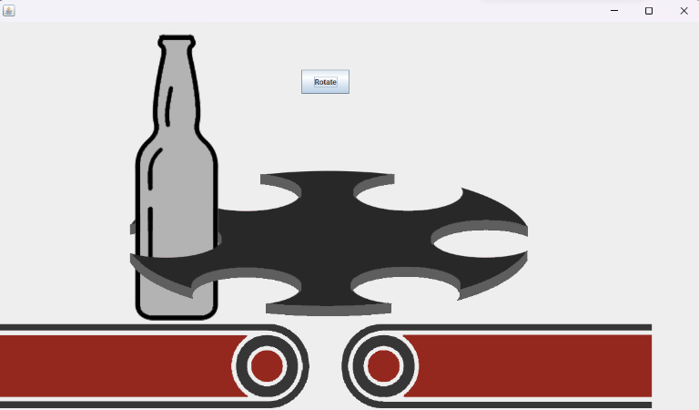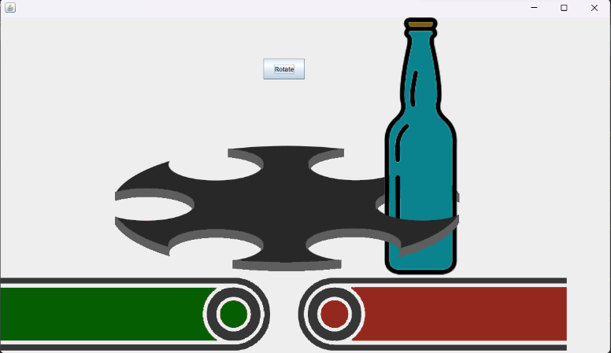

# 6. Assumptions

In developing this system, there were some assumptions taken. This section is to express and explain the main assumptions taken when developing this. Of course this is subject to change as the system is developed, but at the time of writing below are the assumptions made.

1. For the overall design, it is assumed that the separate do not all have to be synchronous with each other, hence the decision to decentralize them. For more information on the justification for a decentralized approach, refer to section 3
2. For the ACS, the IDs to be logged for tracking and access are unique integer values. This is to use a simple data structure of an array of integer values to store, access and compare the IDs for the ACS.
3. For the ABS, it is assumed that there is no need to develop a system for the bottles before and after they are processed through the ABS. That there will be some other method of taking the bottles off to logistics or out of the zone does not need to be considered. This is due to this likely being done by extending the conveyor belt, having them fall into a placed bin or taken by hand.

# 7. Task Allocation

Below is a table showing how each task is categorized, as well as who is currently selected to complete this task

|  |  |  |
| --- | --- | --- |
| **Task** | **Description** | **Allocated to** |
| *ABS Tasks* |  |  |
| Capping Station | Developing the Lip Loader component of the ABS | Frank |
| Bottle Unloader | Developing the Bottle Unloader component of the ABS | Beck |
| Rotary Table | Developing the Rotary Table component of the ABS | Rufaro |
| Conveyor Belt | Developing the Conveyor Belt component of the ABS | Frank |
| Filler | Developing the Filler Station component of the ABS | Rufaro |
| *Group Components* |  |  |
| GUI | Designing the GUI. GUI will need to be drawn and made able to interact and respond to the underlying design. | Beck |
| Report (Main Editor) | Leading the writing, editing and verifying of the final reports to be submitted to be official documentation on the system developed. | Rufaro |
| Integration | This is the task of combining all the sub-systems, environment components and other components and verifying they all interact as expected | Everyone |
| *Individual Components* |  |  |
| ECS | Environment Control System. Will be developed mainly by one individual. Refer to section 3 for more details on system | Frank |
| POS | Purchase Order System. Will be developed mainly by one individual. Refer to section 3 for more details on system | Beck |
| ACS | Access Control System. Will be developed mainly by one individual. Refer to section 3 for more details on system | Rufaro |